Step By Step to create a Power BI report without Excel

This article will walk you through a step-by-step procedure on creating a Power BI report without Excel.

We recently had a lot of new announcements about PowerBI, embedding components such as Power Pivot, Power Query, Power Map, enabling auto refresh, etc... So I decided to roll up my sleeves and get into it with my new Project Online demo tenant. Moreover, since I'm not a developer, I'm always willing to discover reporting tools which don't require any development skills.

Funny thing (or not...), I still do not have Excel 2013, I'm stuck with an old version of Excel 2010, preventing me from installing the latest Power X add-ons to play with...

So that's it? Obviously not, since Microsoft Power BI preview is now available, allowing you to designer powerful dashboard without even using Excel. See this reference:

[**http://blogs.msdn.com/b/powerbi/archive/2015/03/16/power-bi-preview-now-available-worldwide.aspx**](http://blogs.msdn.com/b/powerbi/archive/2015/03/16/power-bi-preview-now-available-worldwide.aspx)

So how does it work?

First connect to [**https://app.powerbi.com**](https://app.powerbi.com/) with your O365 admin account. Once connected, you'll be able to download Power BI Designer. It is a client application which allows you connecting via odata protocol to your Project Online project data.

|  |
| --- |
| [http://2.bp.blogspot.com/-I3n-oU5WJnY/VZZV4aepQzI/AAAAAAAAGJE/gAqr7Kl10pA/s640/Capture.PNG](http://2.bp.blogspot.com/-I3n-oU5WJnY/VZZV4aepQzI/AAAAAAAAGJE/gAqr7Kl10pA/s1600/Capture.PNG) |
| Figure 1: download Power BI Designer from Power BI Preview |

You'll find all relevant information here:

* [**https://powerbi.microsoft.com/designer**](https://powerbi.microsoft.com/designer)
* [**http://blogs.msdn.com/b/powerbi/archive/2015/05/19/power-bi-designer-may-update.aspx**](http://blogs.msdn.com/b/powerbi/archive/2015/05/19/power-bi-designer-may-update.aspx) for the last update (may 2015)

You'll see that Power BI designer looks like Performance Point, in this old fashion presentation as well in the process of creating dashboards, even though it provides much more features and capabilities.

**In Power BI Designer Preview**

Once downloaded, you first create your odata connection on your Project Online instance. For the example, I retrieved projects data using the following URL:

[**https://mydemo.sharepoint.com/sites/pwa/_api/ProjectData/Projects**](https://mydemo.sharepoint.com/sites/pwa/_api/ProjectData/Projects)

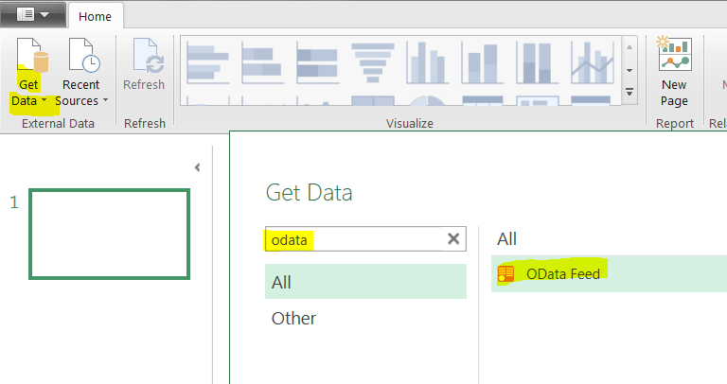

Figure 2: Get the odata source

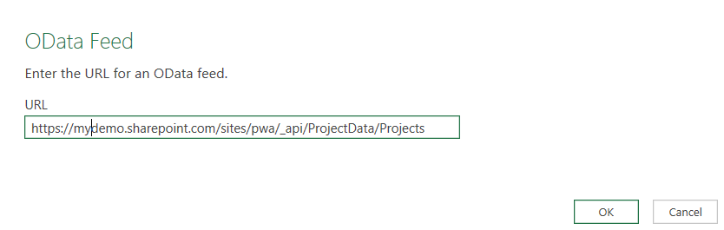

Figure 3: Enter the odata URL

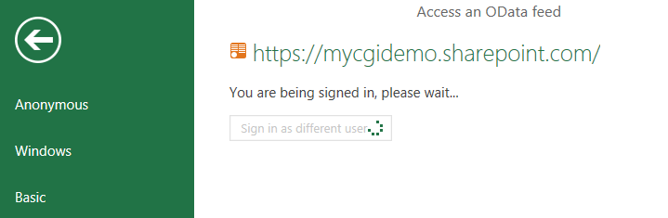

Figure 4: Log in with your O365 account

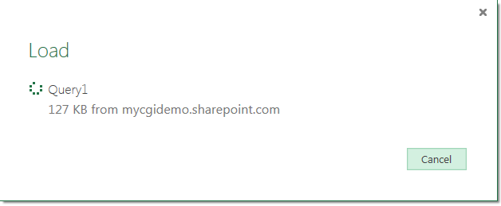

Figure 5: Wait for the data to load

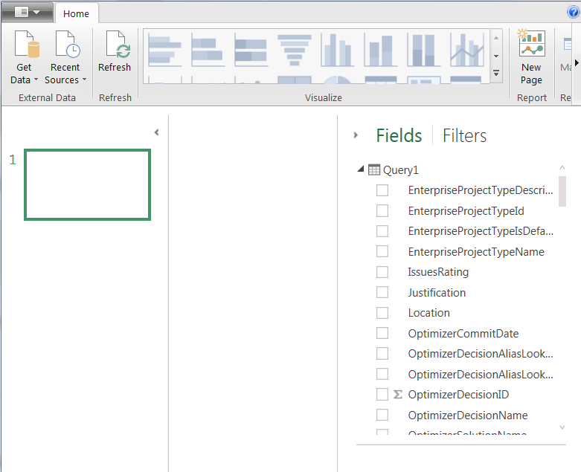

Figure 6: data loaded

Then I won't go into much detail since there are many blogs explaining the process. Here is a very good one, very detailed:

[**https://support.powerbi.com/knowledgebase/articles/471664-getting-started-with-power-bi-designer**](https://support.powerbi.com/knowledgebase/articles/471664-getting-started-with-power-bi-designer)

Since I'm not a developer, I did a simple example, not playing too much with the query part but simply doing simple drag and drop operations and some formatting.

Here my first page:

|  |
| --- |
| [http://2.bp.blogspot.com/-R22m45cvRWE/VZZds7sVcgI/AAAAAAAAGJU/qIupKixSC38/s640/Capture.PNG](http://2.bp.blogspot.com/-R22m45cvRWE/VZZds7sVcgI/AAAAAAAAGJU/qIupKixSC38/s1600/Capture.PNG) |
| Figure 7: dashboard's first page |

And the second one:

|  |
| --- |
| [http://3.bp.blogspot.com/-oBwwqmiZ4CA/VZZd9-lkbiI/AAAAAAAAGJc/0U9kCKPgPls/s640/Capture.PNG](http://3.bp.blogspot.com/-oBwwqmiZ4CA/VZZd9-lkbiI/AAAAAAAAGJc/0U9kCKPgPls/s1600/Capture.PNG) |
| Figure 8: dashboard's second page |

Note that you have more advanced features such as the maps, or you can also edit the query if you are willing to, create relationships, measures and so one...

Once done, you can save your dashboard as a Power BI file (pbix format).

**In Power BI Preview**

Back in Power BI Preview, you can upload your dashboard. As you can see, uploading my dashboard from local drive to Power BI preview will create a data set, a report and a dashboard which can be shared will my colleagues.



Figure 9: upload data in PowerBI App

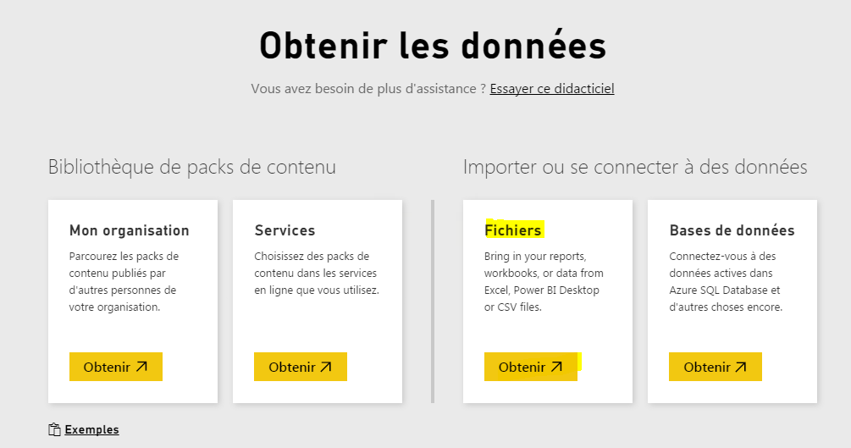

Figure 10: choose “file”

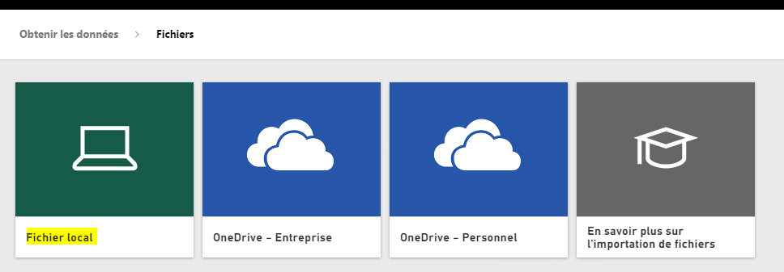

Figure 11: pick-up your pbix file on your local drive

Finally, I'll like to share 2 interesting features:

**1- Q&A**: you can type a question using a formal language in order to find information based on your data set. This will return a graph with eventually a table, together with smart suggestions.

|  |
| --- |
| [http://3.bp.blogspot.com/-vaG3lqvnJHo/VZZilzORmtI/AAAAAAAAGJo/wEVEziqPr5c/s640/Capture.PNG](http://3.bp.blogspot.com/-vaG3lqvnJHo/VZZilzORmtI/AAAAAAAAGJo/wEVEziqPr5c/s1600/Capture.PNG) |
| Figure 12: Q&A feature |

From [**July 15th 2015**](http://blogs.msdn.com/b/powerbi/archive/2015/07/15/new-capabilities-added-to-power-bi.aspx), visualizations, Filter, and Field panes have been added to the Q&A. If I want to change the visual from line to bar chart, I just click on the bar chart icon.  Want to add a field to the visual, just click on the field or drag the field over to the appropriate location.

|  |
| --- |
| [http://3.bp.blogspot.com/-rimY6oSecD8/Vaj2hLJKInI/AAAAAAAAGQE/5Khw5WrgUfE/s640/Capture.PNG](http://3.bp.blogspot.com/-rimY6oSecD8/Vaj2hLJKInI/AAAAAAAAGQE/5Khw5WrgUfE/s1600/Capture.PNG) |
| Figure 13: visualizations pane added to the Q&A |

**2- Schedule auto refresh**: you can now schedule an odata auto refresh to keep your report up to date. See the article:

[**http://blogs.msdn.com/b/powerbi/archive/2015/06/22/announcing-refresh-support-for-power-bi-designer-files-in-the-power-bi-service.aspx**](http://blogs.msdn.com/b/powerbi/archive/2015/06/22/announcing-refresh-support-for-power-bi-designer-files-in-the-power-bi-service.aspx)

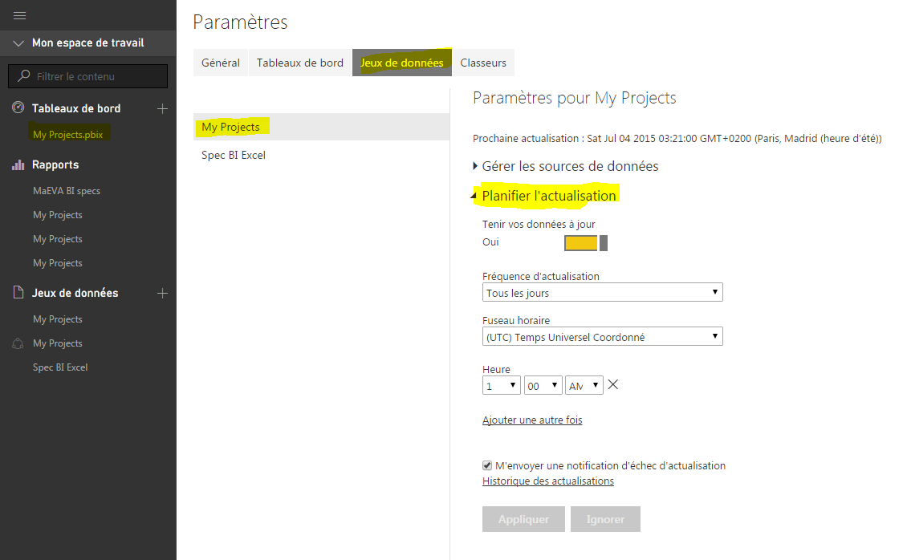

Figure 14: schedule your dashboard auto refresh

And just a last one for fun, where I used a "location" project custom field for a map chart in Power BI Designer to display the total projects costs by country with a slicer and a pie chart associated.

|  |
| --- |
| [http://1.bp.blogspot.com/-o9_K4KuP9Ws/VZZ5Pd57wxI/AAAAAAAAGJ4/P0mGY9W04UE/s640/Capture.PNG](http://1.bp.blogspot.com/-o9_K4KuP9Ws/VZZ5Pd57wxI/AAAAAAAAGJ4/P0mGY9W04UE/s1600/Capture.PNG) |
| Figure 6: map chart with aa "location" project custom field, a slicer and a pie chart |

Nice, isn't it?? That was just a simple example with a simple dataset and light formatting, but imagine what you could do spending a little more time on it!!

**EDIT:** sorry in advance for the video small size. I just tried a new capture tool and it seems like I can't get a bigger size..

Haut du formulaire